

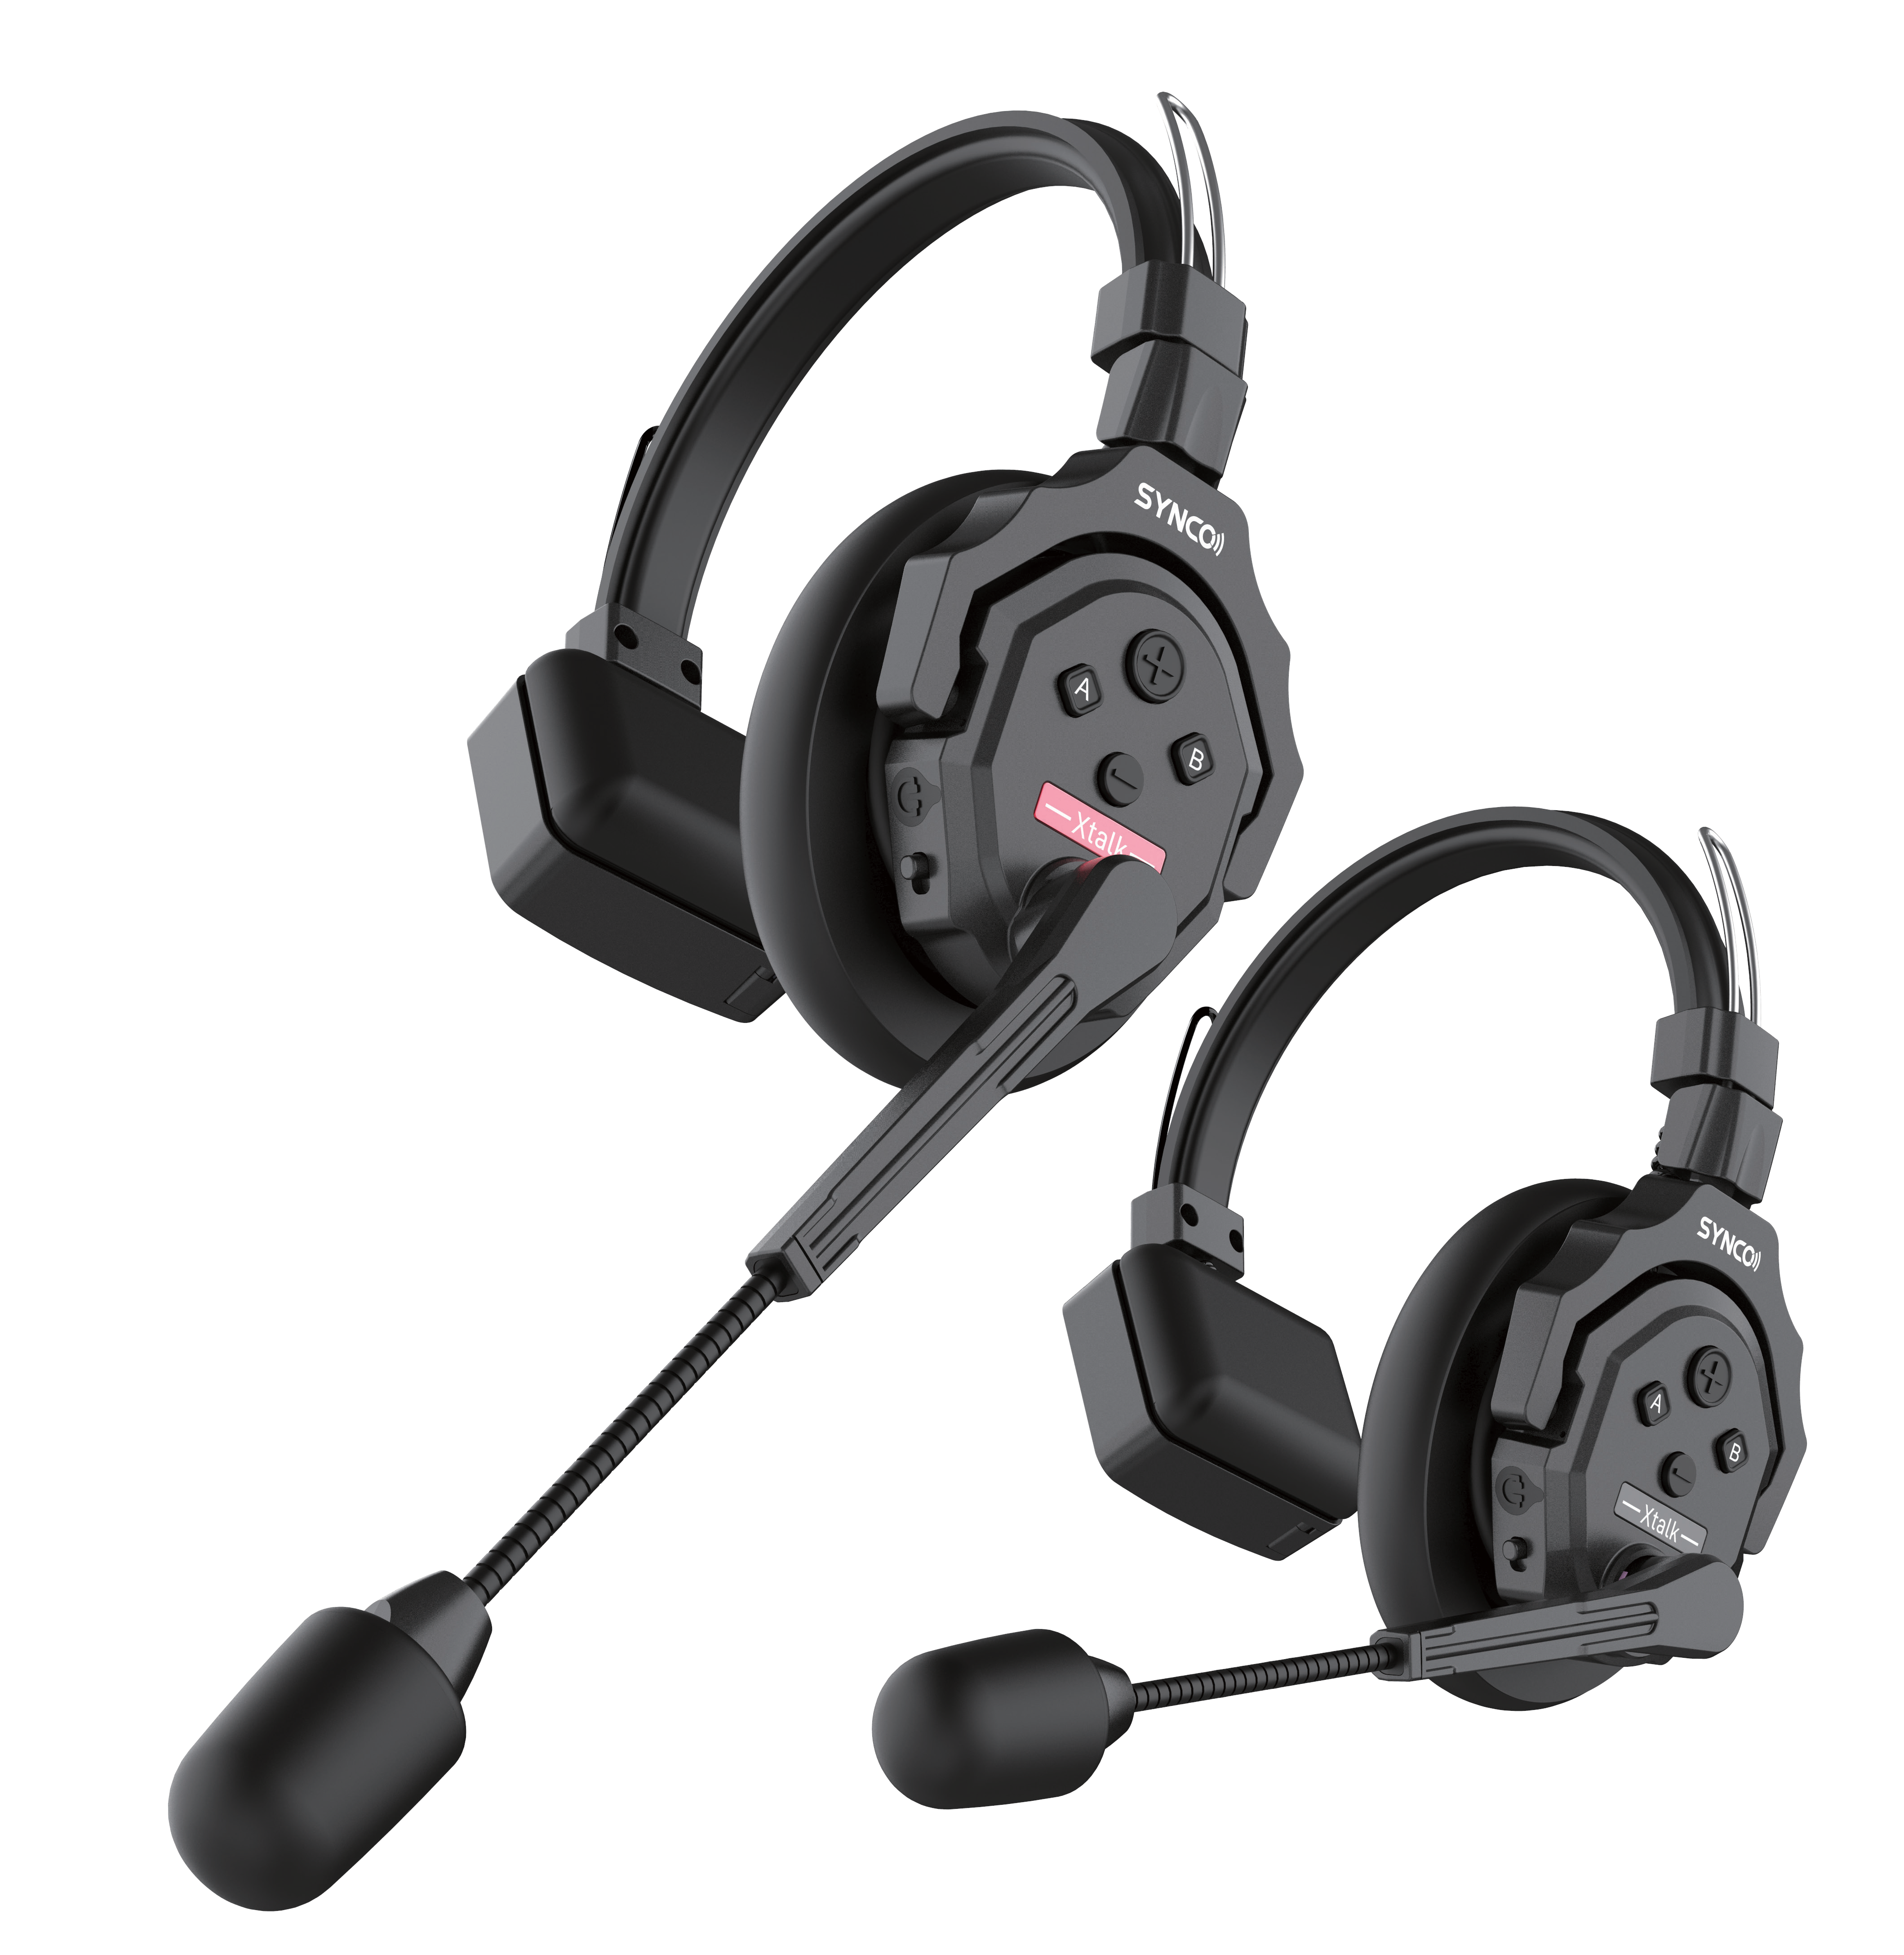

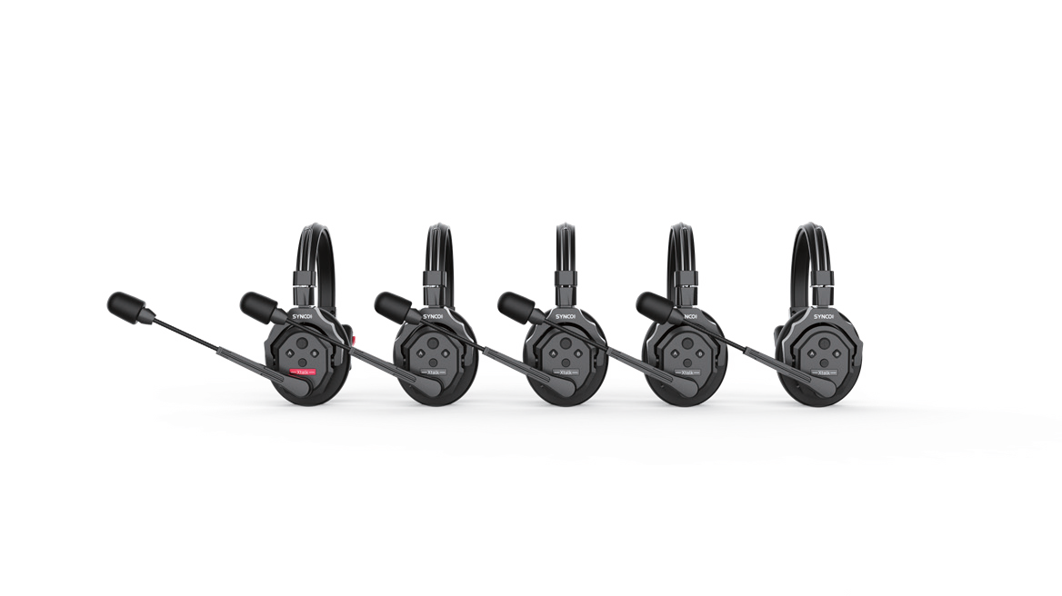
2.4GHz Wireless Intercom System
XTalk V5


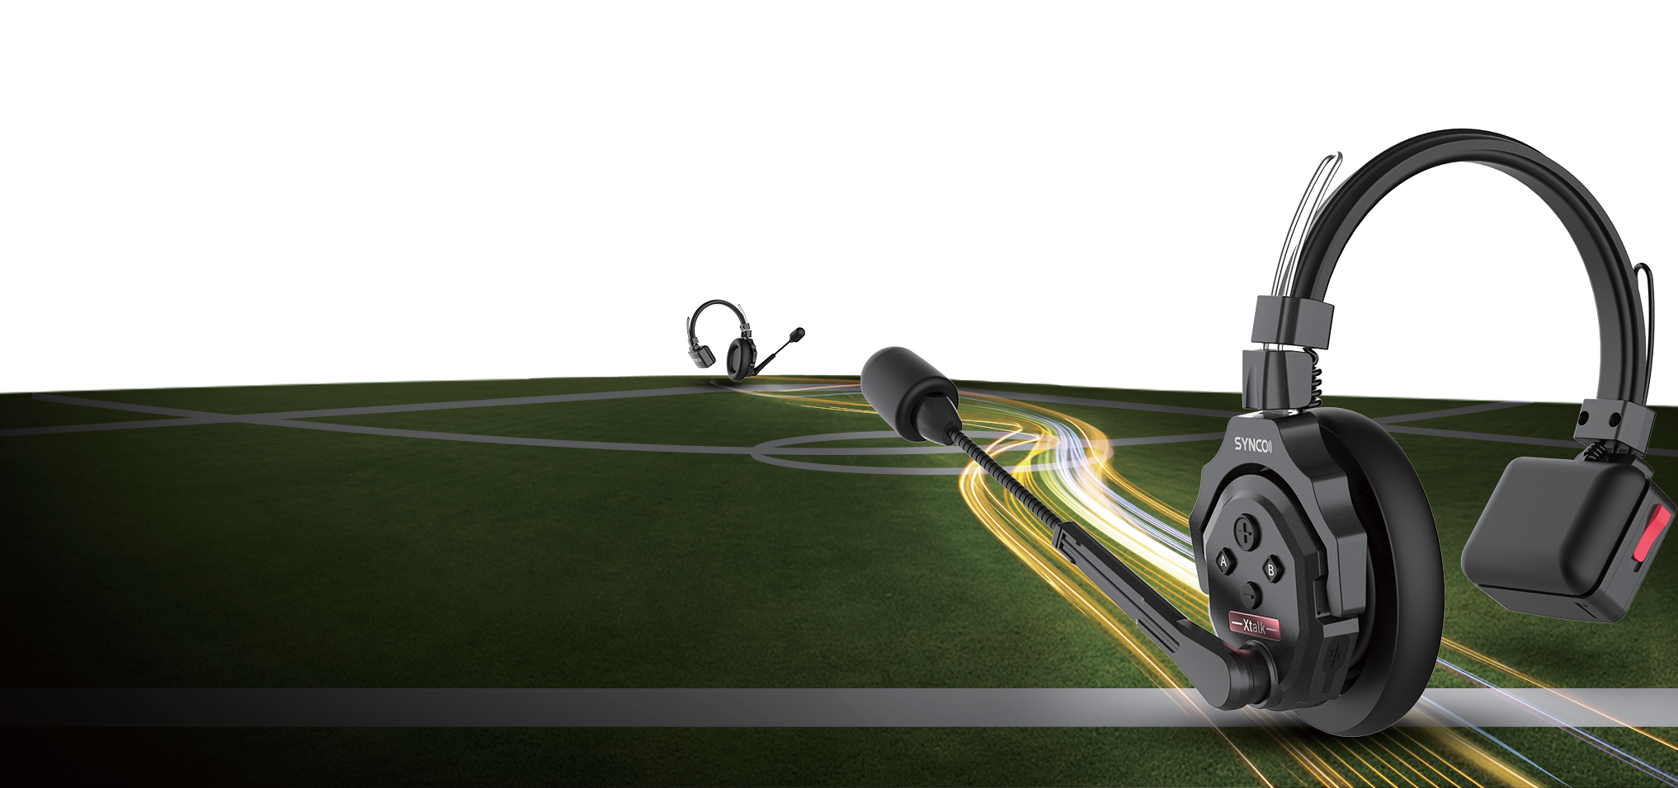
STAY LINKED UP TO 400M DISTANCE
Stay effortlessly connected extensive range of 400m/1,312ft (LOS), This state-of-the-art wireless intercom system is tailor-made for a myriad of prestigious occasions such as church services, TV shows, filmmaking, live performances, and beyond.
2.4GHZ FREQUENCY FOR UNRIVALED CONNECTIVITY & SECURITY
XTALK V5 is the first and only wireless intercom headset system that equips the 2.4GHz frequency to deliver TOP stability and reliability.


AUDIO WITH AEC SPANNING FROM 150HZ TO 7KHZ
Experience unrivaled audio clarit, equipped with advanced AEC technology. This cutting-edge feature eliminates echoes, reverberation, and unwanted ambient noise within the expansive frequency response range of 150Hz to 7kHz.

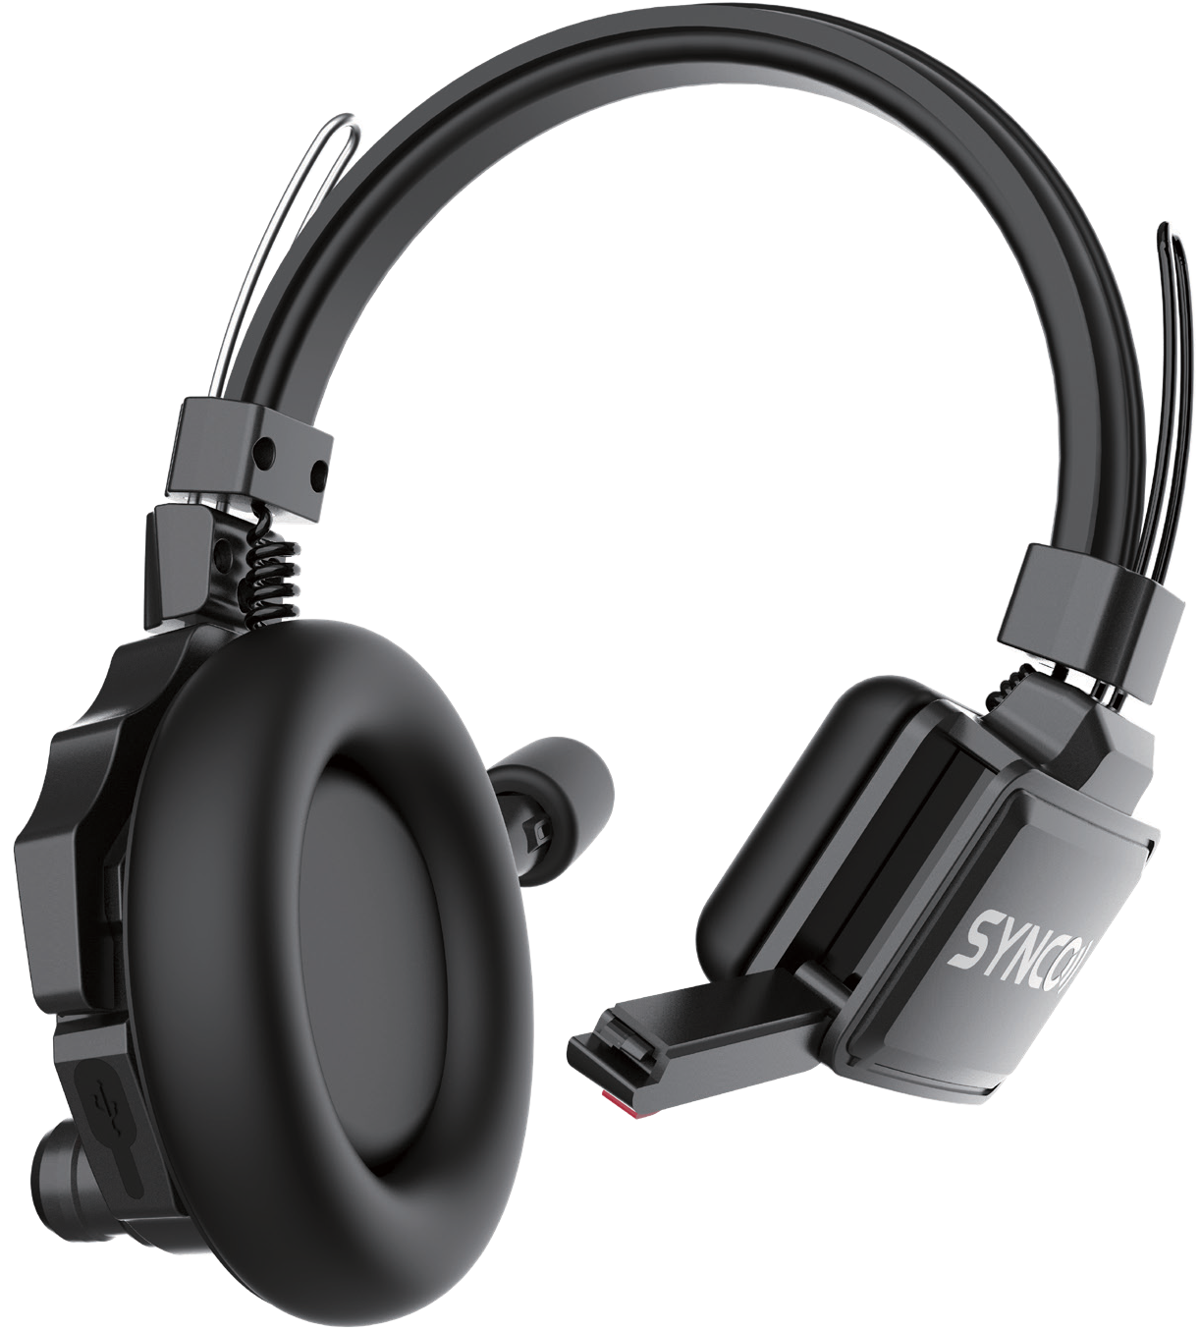OPTIMIZED PORTABILITY AND DURABILITY FOR ON-THE-GO

≈170g
Crafted from lightweight ABS materials, XTALK V5 weighs just 170g (6oz) with the battery included, ensuring comfort during extended use. The upgraded over-ear leather cushion is designed to fit the ear, providing enhanced stability and comfort, making it ideal for challenging work environments.

CONNECT ALL DAY WITH RECHARGEABLE AND REPLACEABLE BATTERIES
Ensures you to easily power up your headset for working over 25H, while the replaceable battery feature allows you to swap in a fully charged backup. Stay connected and communicative throughout your day.

NOISE CANCELLATION AT YOUR SINGLE FINGERTIPS
With a simple press of the button, activate the cutting-edge noise cancellation feature to capture crystal-clear sound with unmatched efficiency. allowing you to focus on what matters most – effective and clear communication.

PRODUCT INFORMATION

Range | 400m/ 1,312ft LOS | Battery Capacity | 1200mAhLi-ion Battery
Frequency Information | 1787MHz-1928MHz | Frequency Response | 150Hz~7khz
Transmission Latency | ＜35ms | Charging Time | 2.5H
Headset Runtime | Master Headset≈10H,Remote Headset≈5H | ignal-To-Noise Ratio | ＞65db
Output Sound Pressure Level | Typical 98±3dbSPL (at 94dBSPL 1KHz) | Distortion | ＜1%
Temperature Range | Working Status：0~45°,Storage Status：-20°~+60° | Microphone Type | Condenser Microphone
Max Input Sound Pressure Level | >115dBSPL | Weight | 170g（Battery Included）

